

NATIONAL UNIVERSITY OF SCINCE AND TECHNOLOGY

FUNDAMENTALS OF PROGRAMMING

SUBMITTED TO:MUHAMMAD AFFAN

SUBMITTED BY:HAMAD ARSHAD

SECTION:ME-15(A)

REG # 481644

TASK NO 1:

# 

**RESULTS:**

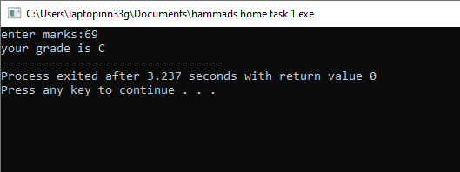

TASK NO 2:

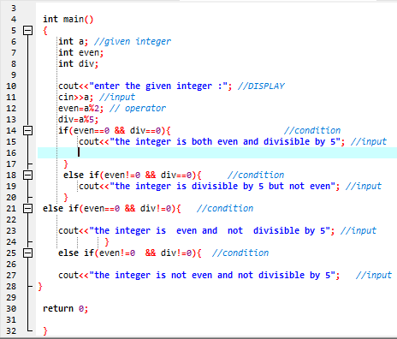

## RESULTS:

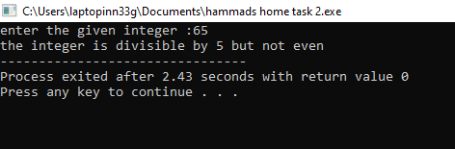

TASK NO 3:

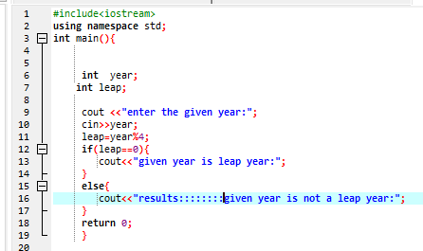

# RESULTS:

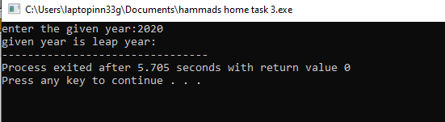

TASK NO 4:

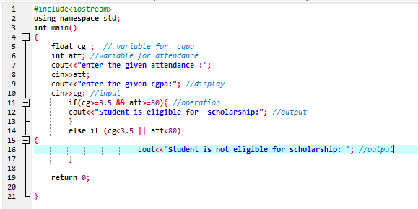

# RESULT:

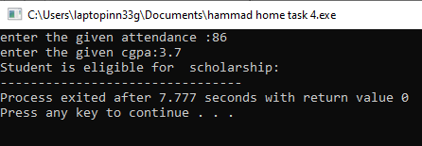

TASK NO 5:

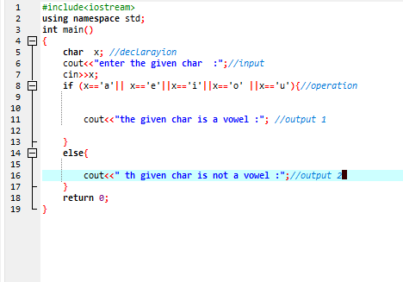

# RESULT:

